Maya and Nathan

Project Overview

Our project was adapting the game asteroids to fit our fantasies. The current version of our game has four themes – Star Wars, Star Trek, Harry Potter, and classic Disney. An object flies around the screen, trying to shoot down opponents and not get hit. Before that happens, there’s a menu that asks you what theme you’d like to play. When you lose, you get a “Game Over” screen, which tells you your score, and lets you leave the game.

Results

We started off with an MVP of just a functioning game. This version had only the Star Wars theme, and didn’t include any of the menus. Once we got that working, we started adding other elements. The first thing we added on was a menu screen that allowed a user to click “start” to start the game, or “quit” to leave it. This menu could be accessed using the escape button. Once we knew that worked, we knew we could begin to implement our themes.

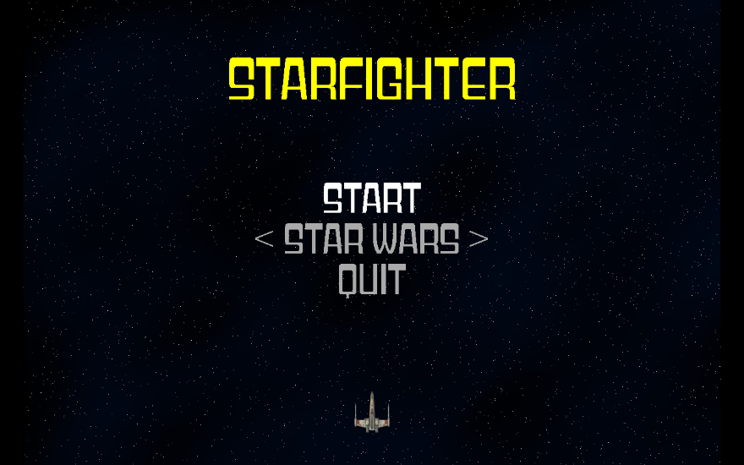

The final has a version of the first start menu, but with an added option to pick a theme. We have the four themes in place, all with different characters and pieces. Once a character gets hit, the game over screen tells them their score.

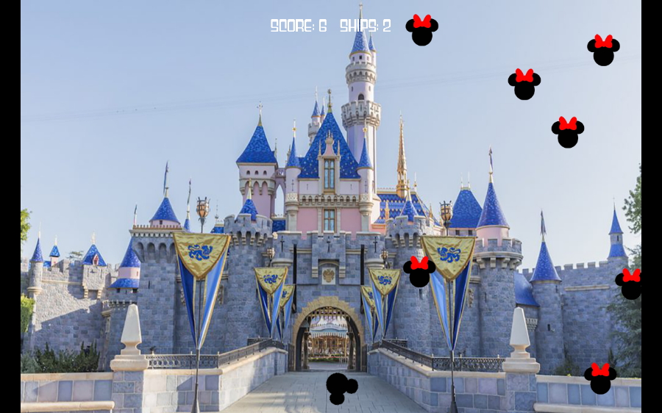

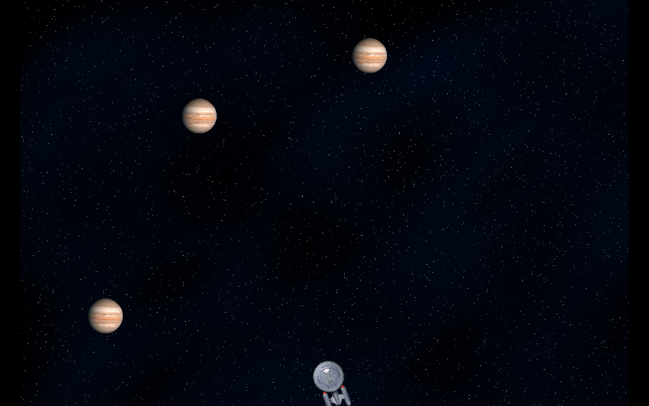

Implementation

We have several different classes: Ship (which is the character the player control), Bolts (which is the thing shot by player), Enemies (which is what you shoot at. Not always an antagonist), Settings (what the game looks like, general parameters), GameStats (which keeps track of statistics such as the score), and Menu (self-explanatory).

For the sake of simplicity, we chose to keep all of our classes housed in different files. We also have a file, game_functions, which houses the functions needed to run the game, and Starfighter, which is where we actually run the game.

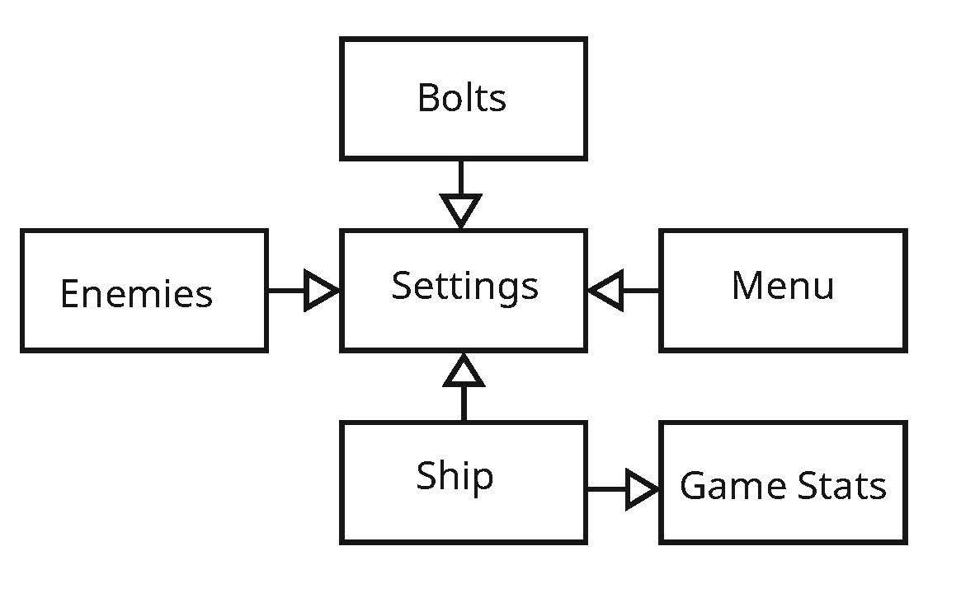

Reflection

We initially struggled coming up with a topic for this project. We dedicated two hour long meetings to ideating. Once we settled on a plan, it took very little time for us to come up with ideas on how to move past the MVP. Although we’re both very happy with our final project, we also acknowledge that we could’ve accomplished more given that time.

Because our game is based on a classic arcade game, the learning curve is relatively low. That being said, it does require finger dexterity, and some of the themes might have colors that are harder to see. We could add a version that’s high contrast for people with bad eyesight, or for those who are color blind.

We split the work by topic – for example, Nathan would do the menu, while Maya did the themes. We would code on a shared workspace when possible. Next time, we’d plan who was doing what much earlier, so there would be less ambiguity.